ESCUDOS DE ARMAS DE SALES

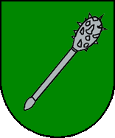
Figure 1, shown here, is the original Coat-of-Arms granted by the Spanish monarch King Jaime I to Don Guillermo de Sales for his bravery and valor in the war where he saved the king’s life. The shield is Vert (green) with an Argent (Silver) club in bend. This particular coat-of-arms was also later on used by the Sales family of Valencia, Spain.

FIGURE 1
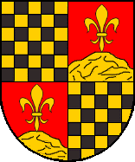
Figure two is the coat-of-arms used by the Sales family situated in the province of Cataluña, Spain. Its description is: Quarterly: 1st and 4th, Chequy Sable(black) and Or (Gold); 2nd and 3rd, Gules (red) with Or single fleur-de-lis over an Or mountain.
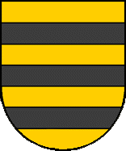
FIGURE 2
The third coat-of-arms, displayed here as figure 3, is the other arms used by the Cataluña branch of the Sales family. It is Or (gold) with three Sable (black) bars in fess.
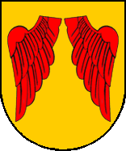

FIGURE 3
Figure four is the coat-of-arms used by the Sales family of Gerona, Spain. It is Or (gold) with two Gules (red) wings.
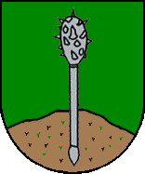
FIGURE 5
Figure 5 is the personal coat-of-arms of Asensi Sales, a former Bishop of Barcelona, Spain, and based on the arms of Don Guillermo de Sales. It is Vert (green) with a single Argent (silver) club situated standing on a mountain.

FIGURE 4

Another arms used by the other branches of the Sales family in Spain is shown here in figure 6. It is Azure (blue) with a single Or (gold) tower standing on a Vert (green) terrace.

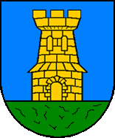
FIGURE 6

Figure 7 shows the Mallorca Sales family’s coat-of arms. It is Quarterly: 1st, Vert (green) a single cross gules (red), 2nd, Azure (blue) two Or (gold) bars in bend, 3rd, Azure (blue) three wavy bars in fess.

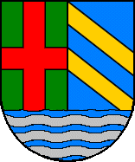
FIGURE 7

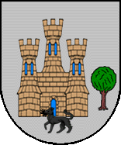
Finally, the last coat of arms, figure 8, is the coat-of-arms used by the Guernica branch of the Sales family of Spain. It is also the oldest existing coat-of-arms of the Sales family, having the motto: “these are the arms with the favors shown by the King of Spain.” It is Argent (silver) with a single triple-towered castle, a Sable (black) wolf, and a tree standing beside the castle.
FIGURE 8

